Yarker resident files legal action against waste transfer facility owner
Neighbour seeking $45,000 in damages after years of off-site impacts including dust, noise, odours and vibration
Author of the article:
Meghan Balogh
Published Oct 10, 2025 • The Kingston Whig Standard
Cathy Martin stands on the property line that divides her front lawn and the Yarker waste transfer facility owned by Westendorp on Sept. 8, 2025. Martin has taken legal action against the company and its owner, claiming negligence in private nuisance after years of dust, noise, odours, vibrations and vermin she believes are a direct result of the waste transfer site's operations. PHOTO BY MEGHAN BALOGH /The Whig-Standard

Article content
YARKER — A local resident has filed a civil action in Ontario Superior Court against a company that owns and operates a waste transfer facility only a handful of metres from her home in the village of Yarker.
Cathy Martin, legally represented by Richard Lindgren of the Canadian Environmental Law Association, filed her statement of claim in small claims court earlier this month against John Westendorp Enterprises, Inc. and John Edward Westendorp personally, claiming “negligence in private nuisance” in relation to Westendorp’s waste transfer facility and its operations.
Last month, the Whig-Standard reported on alleged negative off-site impacts of the waste transfer facility next door to the home that Martin and her son share on County Road 6, a property she purchased in 1992.
Last month, Martin said that living in her home was like living in a “construction zone that never stops,” with noise, vibration, odours and more impacting her life during the site’s operating hours.
The transfer site ramped up operations in 2021 after receiving its environmental compliance approval from the Ministry of the Environment, Conservation and Parks (MECP) to process up to 250 tonnes of recyclable materials and asbestos waste daily.
In her statement of claimed filed in court on Oct. 1, Martin states that the “adverse noise, odour, dust, vermin, overland water flow, and other impacts that she and her son have suffered while residing at the Plaintiff’s property emanated solely from waste-related activities at the waste transfer site.”
The statement of claim points out that Martin’s home is only 20 metres from the property line of the waste transfer facility, around 21 metres from the site’s weigh scales for incoming trucks, and approximately 50 metres from the on-site diesel refuelling station.
As mentioned in the statement of claim, Westendorp’s environmental compliance approval (ECA) outlines permitted and non-permitted uses of the property. For instance, it prohibits the receiving of “putrescible waste” at the site, prohibits the “discharge of a contaminant that causes or is likely to cause an adverse effect,” and prohibits against “nuisance impacts caused by outdoor storage of waste.”
Among other requirements, the statement of claim points out that the ECA requires Westendorp to “operate and maintain the site so that dust, odours, vectors, vermin, birds, litter, noise and traffic do not create a nuisance.”
Despite the noted ECA conditions, reads the statement of claim, Martin’s property, and her use and enjoyment of her property, have “been subject to substantial, unreasonable, and continuing adverse impacts arising from various activities and equipment at the waste transfer site owned and operated by the corporate and personal Defendants.”
Presently, the statement of claim says, Martin experiences “several on-site sources of excessive noise and vibration” from the waste transfer site, including the sound vehicles and heavy equipment such as dump trucks, backhoe, front-end loader, excavator, waste crushing machinery, as well as “back-up beepers, horn honking, truck air brakes, and constant truck traffic to and from the site,” which Martin alleges “creates significant dust problems” that has forced her to keep her windows closed on her home, prevents her from being outside or using her back yard when dust is in the air, and has led to “coughing, choking and difficulty in breathing.”
Martin alleges she experiences “various on-site sources of noxious and offensive odours” such as diesel exhaust, “putrid, nauseating, or rotten odours from municipal garbage deposited outdoors at the waste transfer station,” and “large amounts of dust emanating from the waste transfer site despite dust suppression efforts.”
The site is also operating outside of permitted hours, the statement of claim alleges.
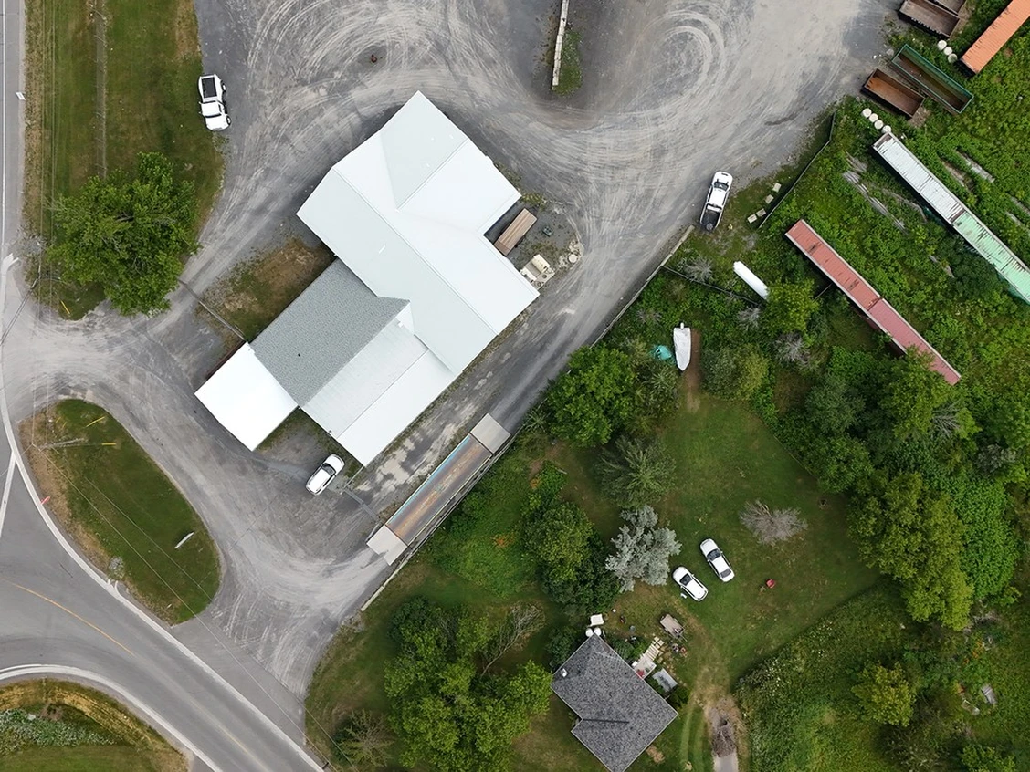

An aerial image shows the waste transfer facility, County Road 6, and Cathy Martin’s house and back yard on July 5, 2025. Supplied photo
These effects have been documented by Martin since 2022, at the recommendation of the Township of Stone Mills and the MECP, the statement of claim says.
That documentation has been submitted to Westendorp, the ministry and the township many times over the years, but “none of these complaints have resulted in any reduction, abatement or prevention of these adverse impacts upon the Plaintiff’s property,” the claim reads.
Martin claims that Westendorp should have known the impacts their operations would have off-site, and that Westendorp — the Defendant — “failed to take adequate steps to prevent, reduce or mitigate such impacts in callous disregard of the Plaintiff’s personal, pecuniary and property-based interests.”
The statement of claim also alleges that the “personal Defendant,” John Edward Westendorp, has “harassed, insulted, threatened, and verbally abused the Plaintiff, and undertaken other forms of intimidation against the Plaintiff.”
Martin is seeking $45,000 in damages, plus interest and legal costs.
Richard Lindgren, Martin’s representation, is a staff lawyer at the Canadian Environmental Law Association, which he told the Whig-Standard represents clients like Martin in court and before tribunals “to ensure access to environmental justice.”
“In the circumstances of this case, it is clear that Cathy Martin required legal assistance to address her long-standing concerns about operations at the waste transfer site,” Lindgren said.
Westendorp declined the opportunity to comment, but the Whig-Standard will report on the filed statement of defence when that becomes available.
mbalogh@postmedia.com

